

Week 10 Assignment

Ujjwal Bhasin - 200389272 | Relational Databases | July 17, 2018

Step 1.

Query-

1)create database my_contacts2;

use my_contacts2;

CREATE TABLE `my_contacts` (

`contact_id` int (11) PRIMARY KEY NOT NULL AUTO_INCREMENT,

`last_name` varchar(30) ,

`first_name` varchar(20) ,

`phone` int(10),

`email` varchar(50) ,

`gender` char(1),

`birthday` date ,

`prof_id` int(10),

`zip_code` int(10),

`status_id` int(10)

);

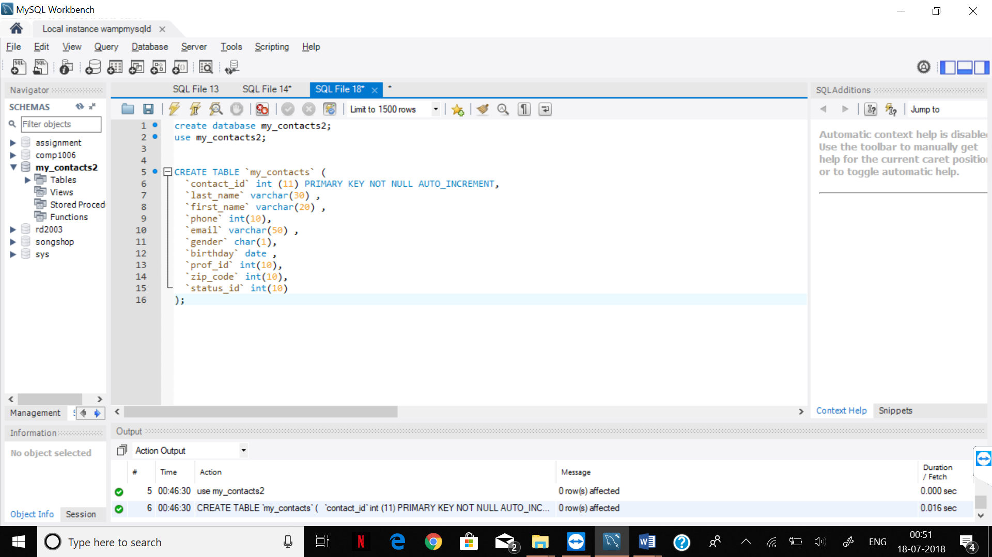

2)INSERT INTO my_contacts VALUES ('1', 'Smith','Singh','1234567890','jill_anderson@ \nbreakneckpizza.com','F','1980-09-05','12','123','1234');

INSERT INTO my_contacts VALUES ('2', 'Kevin','Leo','1234567830','lkenton@starbuzzcoffee.com','M','1974-01-10','23','234','2345');

INSERT INTO my_contacts VALUES ('3', 'Garry','Darrin','6476493361',' captainlove@headfirsttheater.com','M','1966-01-23','34','345','3456');

INSERT INTO my_contacts VALUES ('4', 'Malek','Joe','6476476477','joe_franklin@leapinlimos.com','M','1977-04-28','45','456','4567');

INSERT INTO my_contacts VALUES ('5', 'Ashlyn','Jamie','7056478899','dontbother@starbuzzcoffee.com','F','1964-09-10','56','567','5678');

INSERT INTO my_contacts VALUES ('6', 'Aly','Maurice','6477056677','bookman4u@objectville.net','M','1962-07-01','67','678','6789');

INSERT INTO my_contacts VALUES ('7', 'Navreet','Renee','7058899445','poorrenee@mightygumball.net','F','1976-12-03','78','789','7890');

INSERT INTO my_contacts VALUES ('8', 'Mandi','Angelina','6475678844','angelina@starbuzzcoffee.com','F','1979-08-19','89','890','8901');

INSERT INTO my_contacts VALUES ('9', 'Susa','Donald','4567894455','padraic@tikibeanlounge.com','M','1967-01-23','90','901','9012');

INSERT INTO my_contacts VALUES ('10', 'Spartan','John','6578761122','jpoet@objectville.net','M','1963-04-18','01','012','0123');

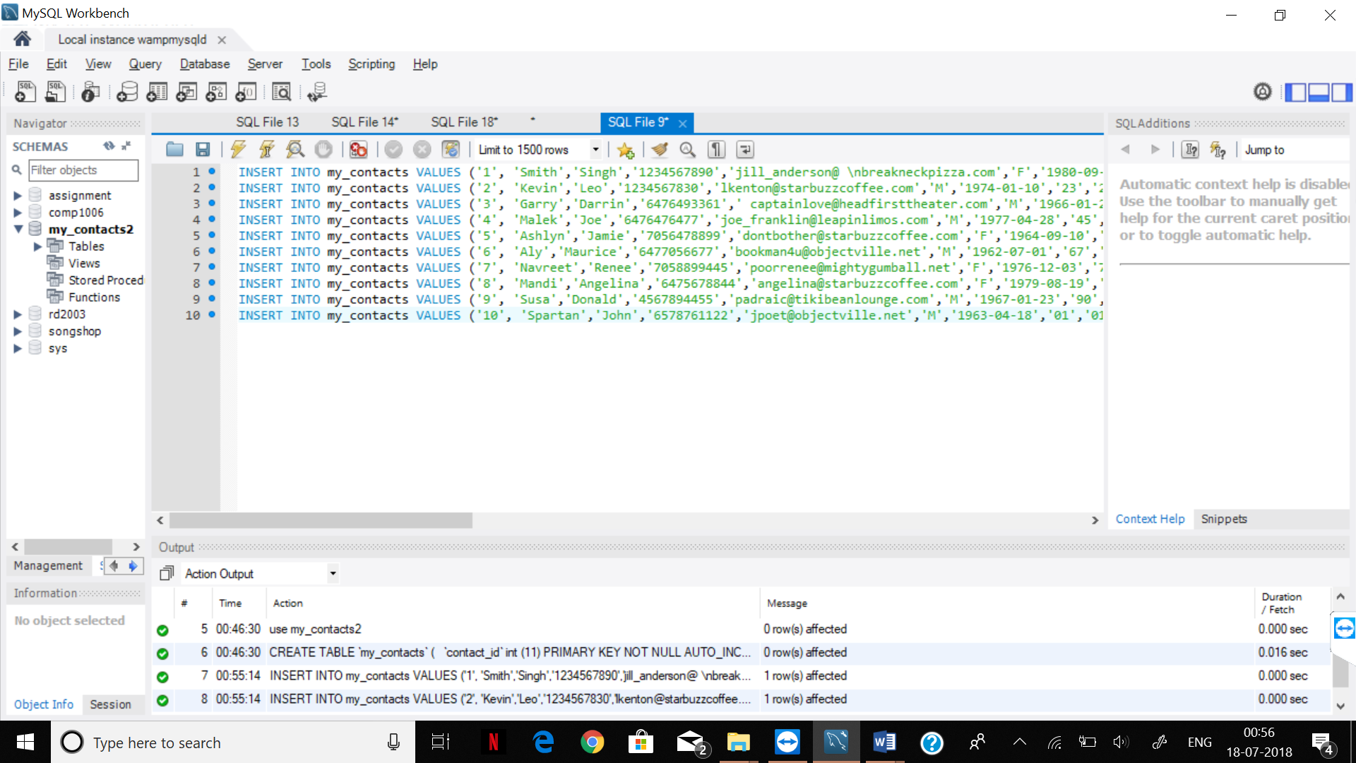

Step 2

Query

1)use my_contacts2;

create table `interests`(

`interest_id` int(11) primary key not null,

`interest` varchar(50) not null

);

create table `seeking`(

`seeking_id` int(11) primary key not null,

`seeking` varchar(50) not null

);

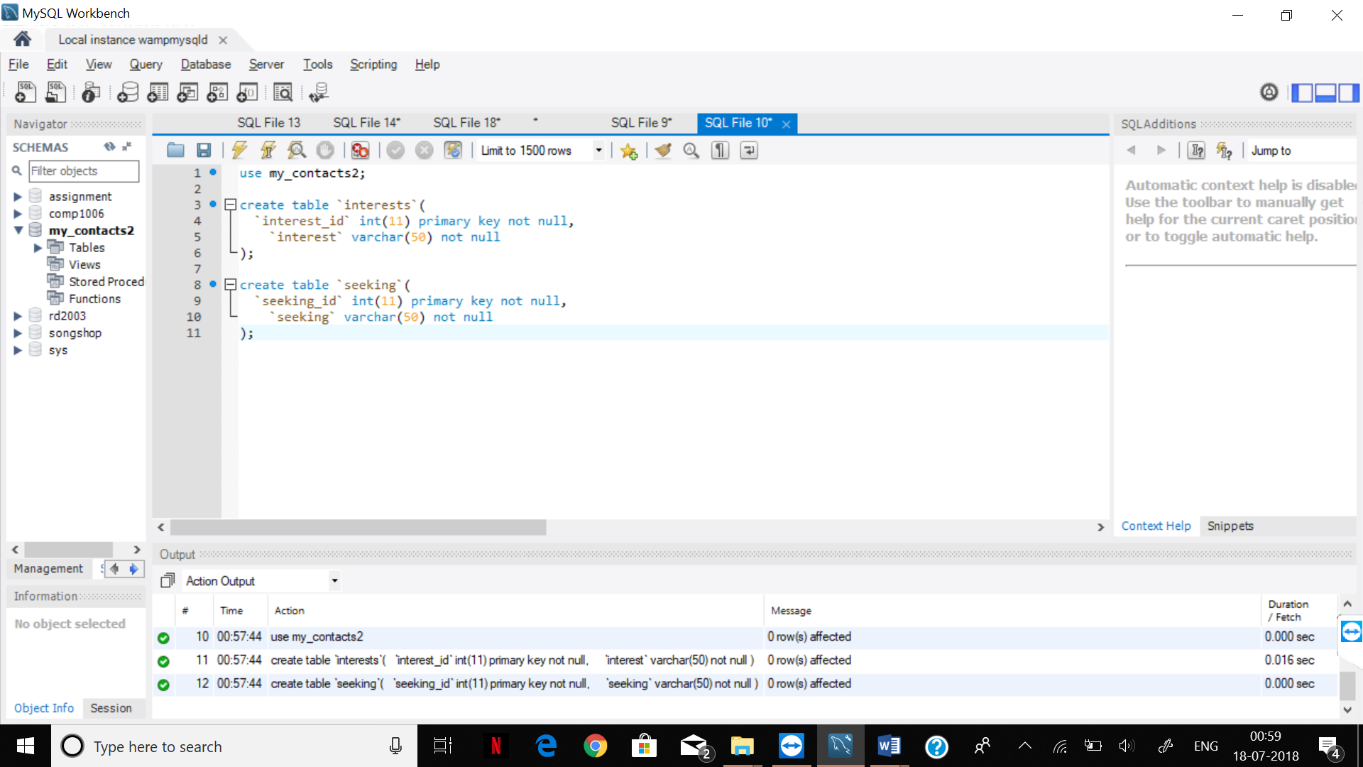

2) USE my_contacts2;

CREATE TABLE `contact_interest` (

`contact_id` int(11) NOT NULL,

`interest_id` int(11) NOT NULL,

CONSTRAINT my_contacts_contact_id_fk

FOREIGN KEY (contact_id)

REFERENCES my_contacts (contact_id),

CONSTRAINT interests_interest_id_fk

FOREIGN KEY (interest_id)

REFERENCES interests (interest_id)

);

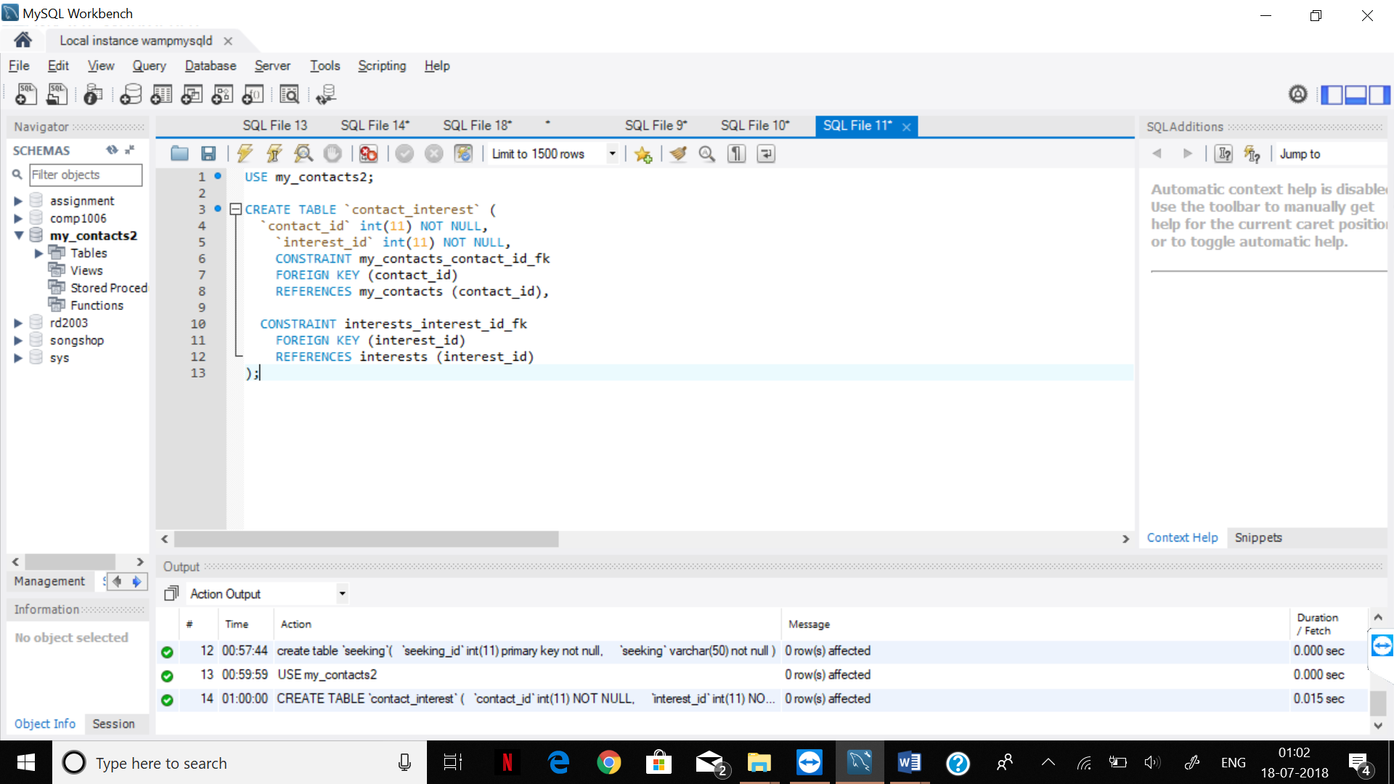

3) USE my_contacts2;

CREATE TABLE `contact_seeking` (

`contact_id` int(11) NOT NULL,

`seeking_id` int(11) NOT NULL,

CONSTRAINT my_contacts_contact_id_fk_a

FOREIGN KEY (contact_id)

REFERENCES my_contacts (contact_id),

CONSTRAINT seeking_seeking_id_fk

FOREIGN KEY (seeking_id)

REFERENCES seeking (seeking_id)

);

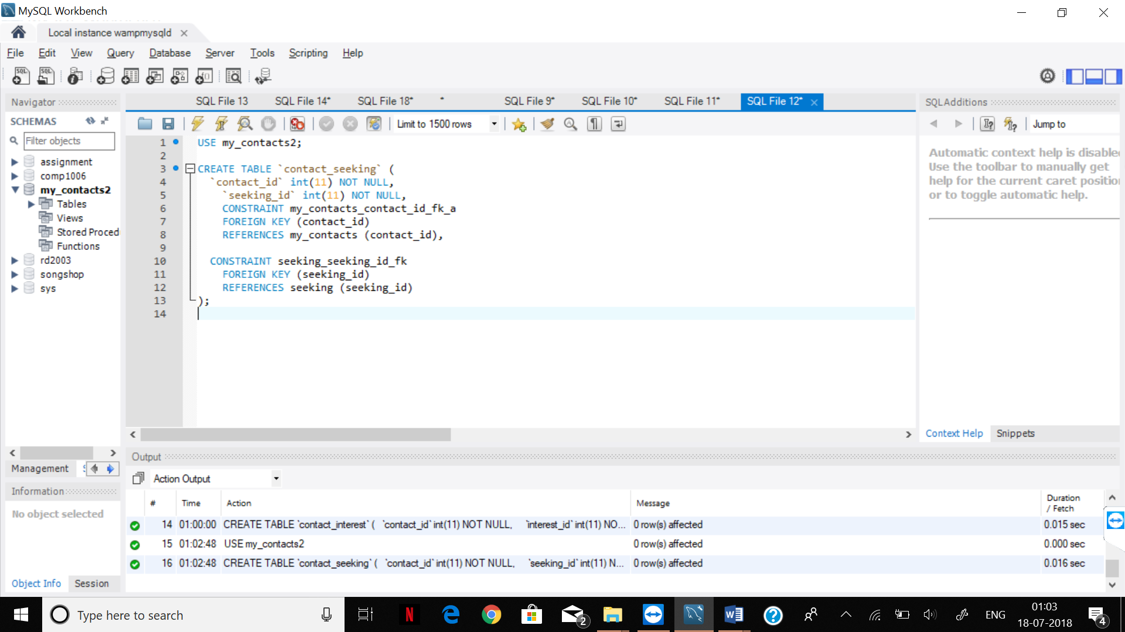

4) use my_contacts2;

create table `profession`(

`prof_id` int(11) primary key not null,

`profession` varchar(50) not null

);

create table `zip_code`(

`zip_code` int(11) primary key not null,

`city` varchar(10) not null,

`state` varchar(10) not null

);

create table `status`(

`status_id` int(11) primary key not null,

`status` varchar(50) not null

);

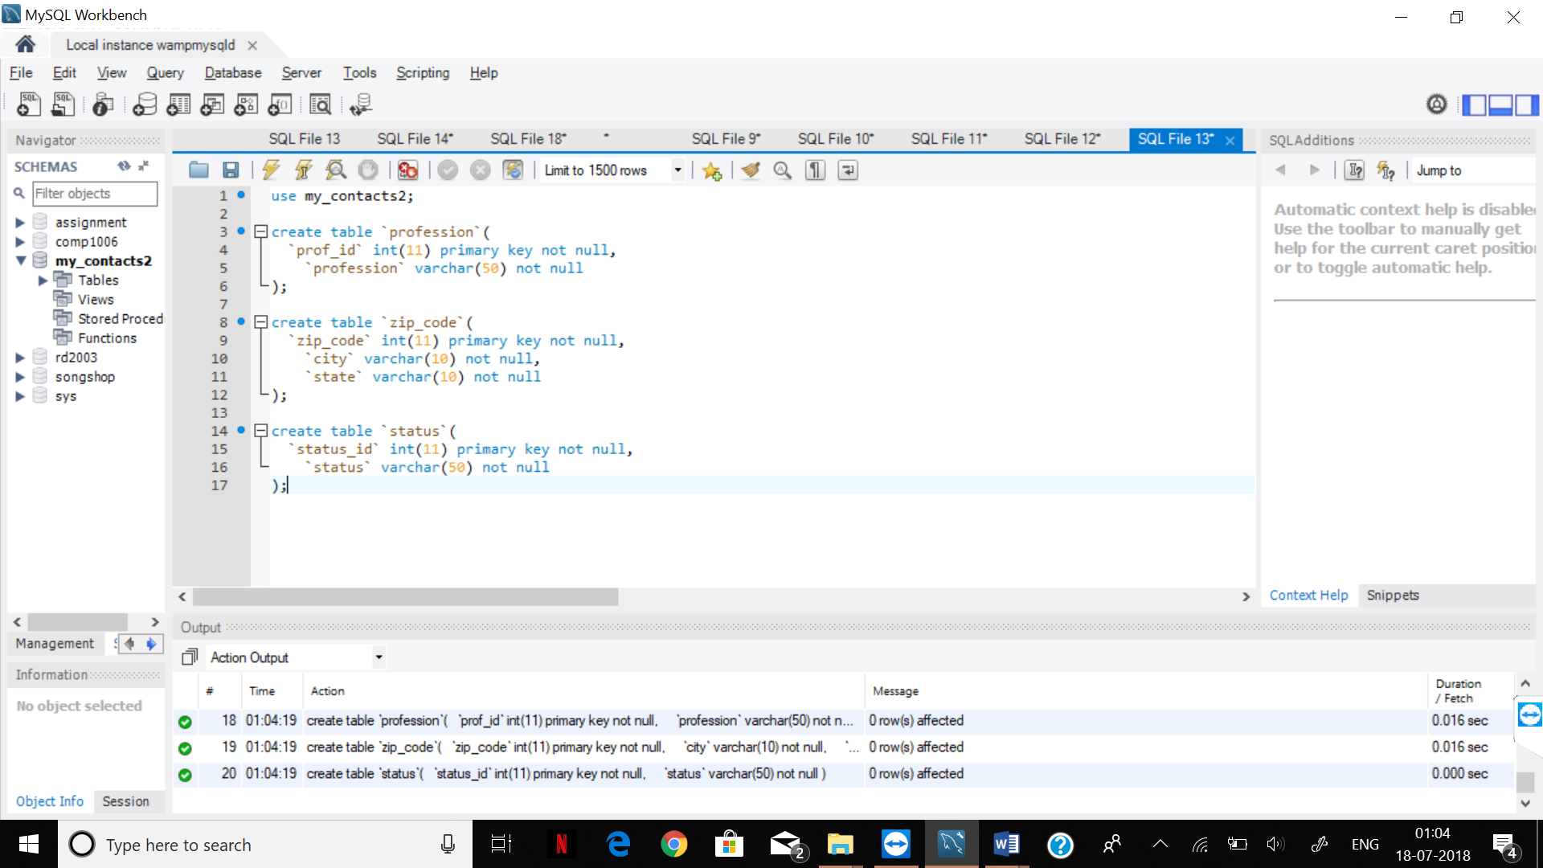

5) ALTER TABLE `my_contacts`

ADD CONSTRAINT `prof_id`

FOREIGN KEY (`prof_id`)

REFERENCES `profession` (`prof_id`);

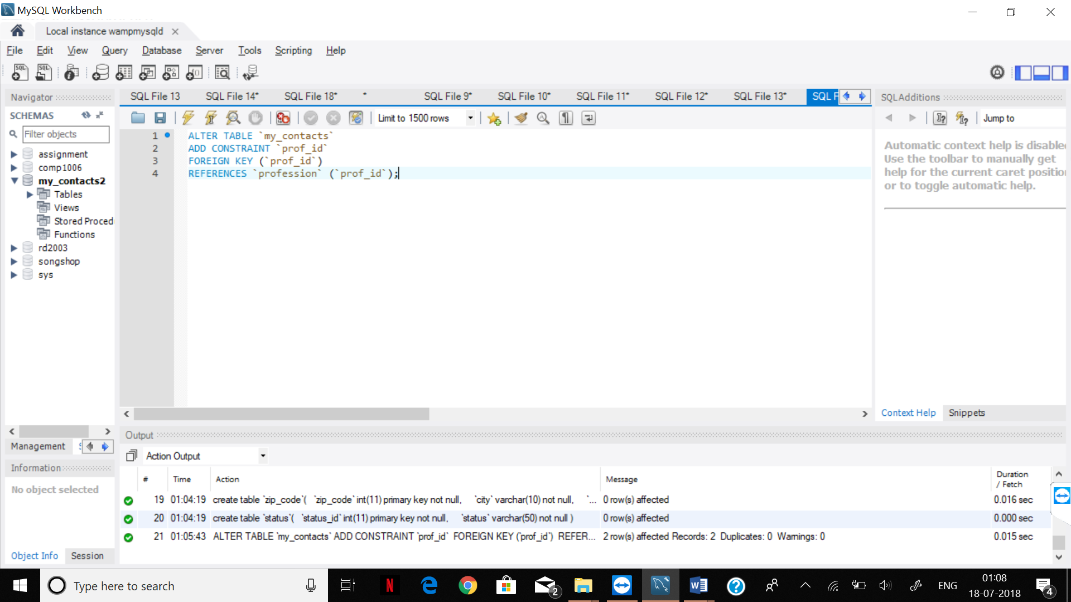

6) ALTER TABLE `my_contacts`

ADD CONSTRAINT `zip_code`

FOREIGN KEY (`zip_code`)

REFERENCES `zip_code` (`zip_code`);

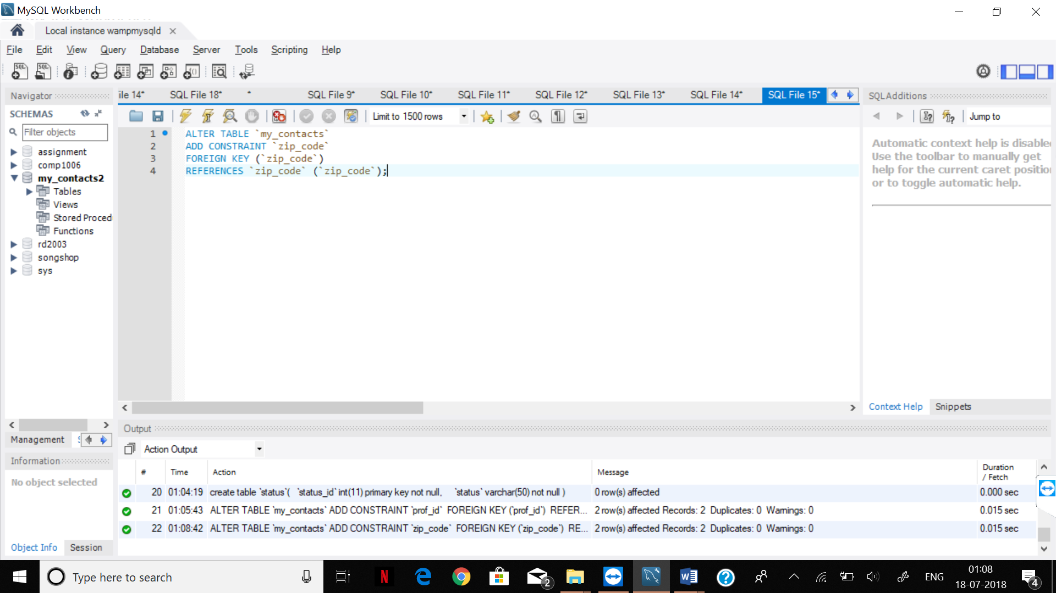

7) ALTER TABLE `my_contacts`

ADD CONSTRAINT `status_id`

FOREIGN KEY (`status_id`)

REFERENCES `status` (`status_id`);

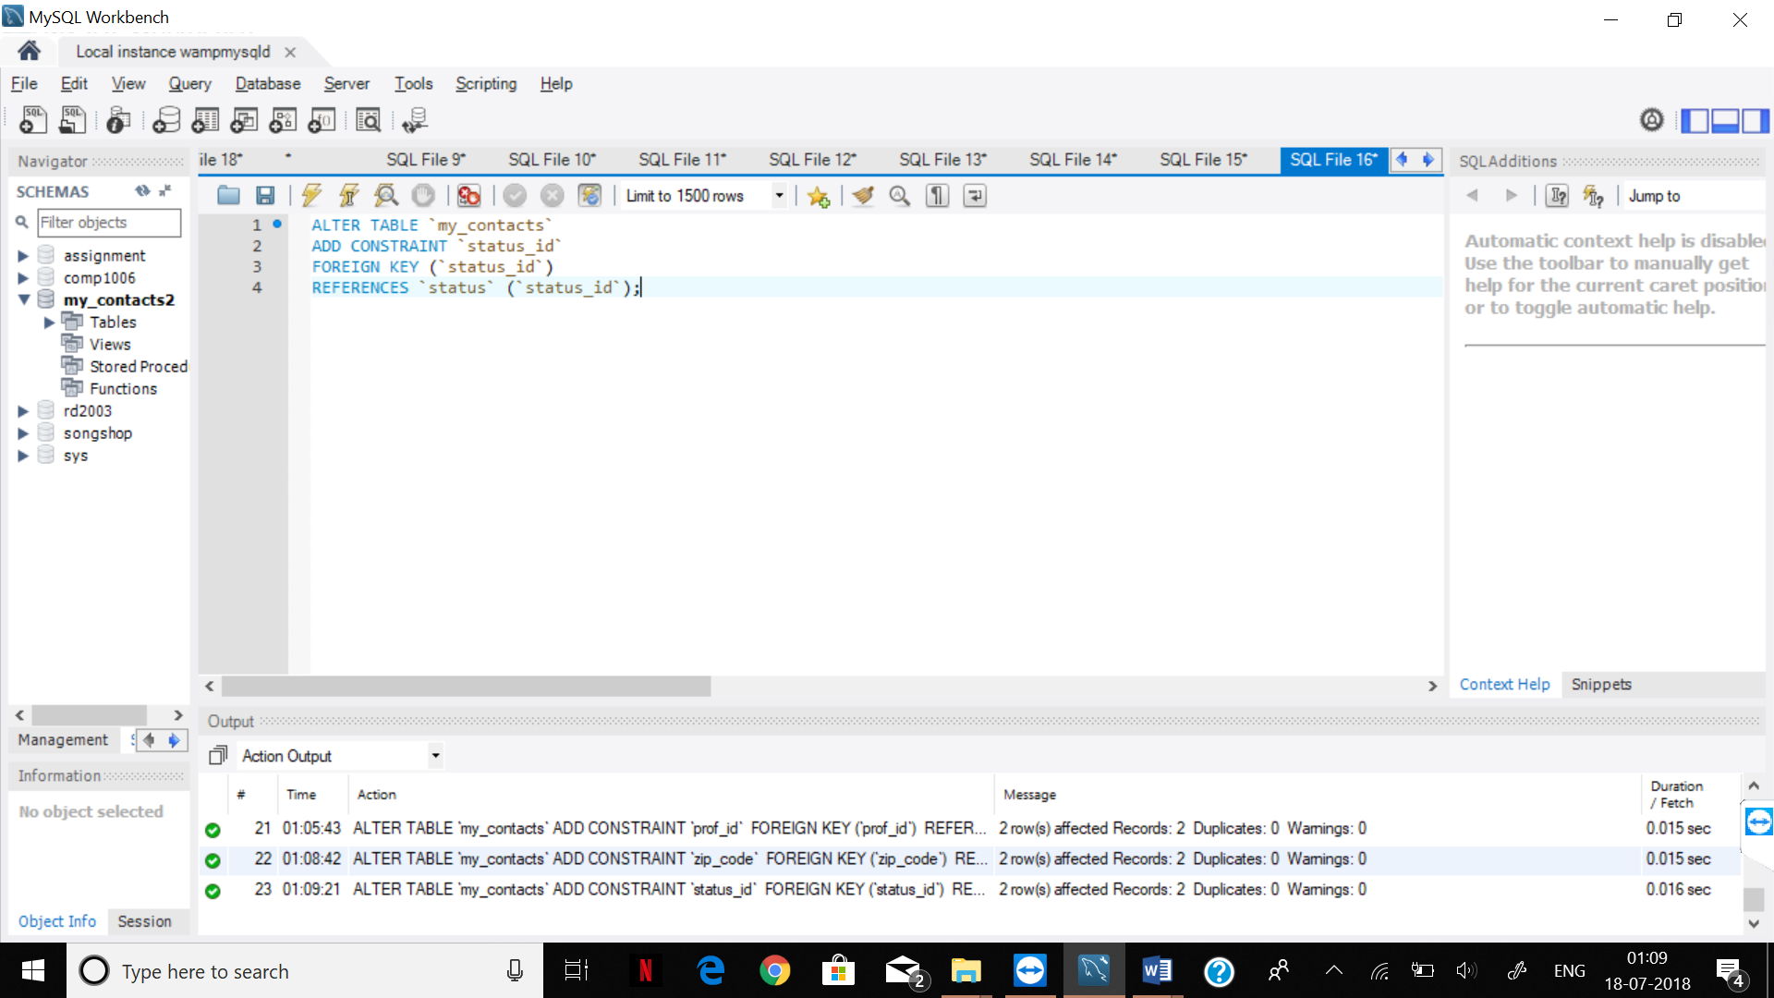

Step 3

Query

1) insert into profession values ('1','baller');

insert into profession values ('12','footballer');

insert into profession values ('23','astronomer');

insert into profession values ('34','manager');

insert into profession values ('45','dentist');

insert into profession values ('56','astrologer');

insert into profession values ('67','programmar');

insert into profession values ('78','enemy');

insert into profession values ('89','crickter');

insert into profession values ('90','professor');

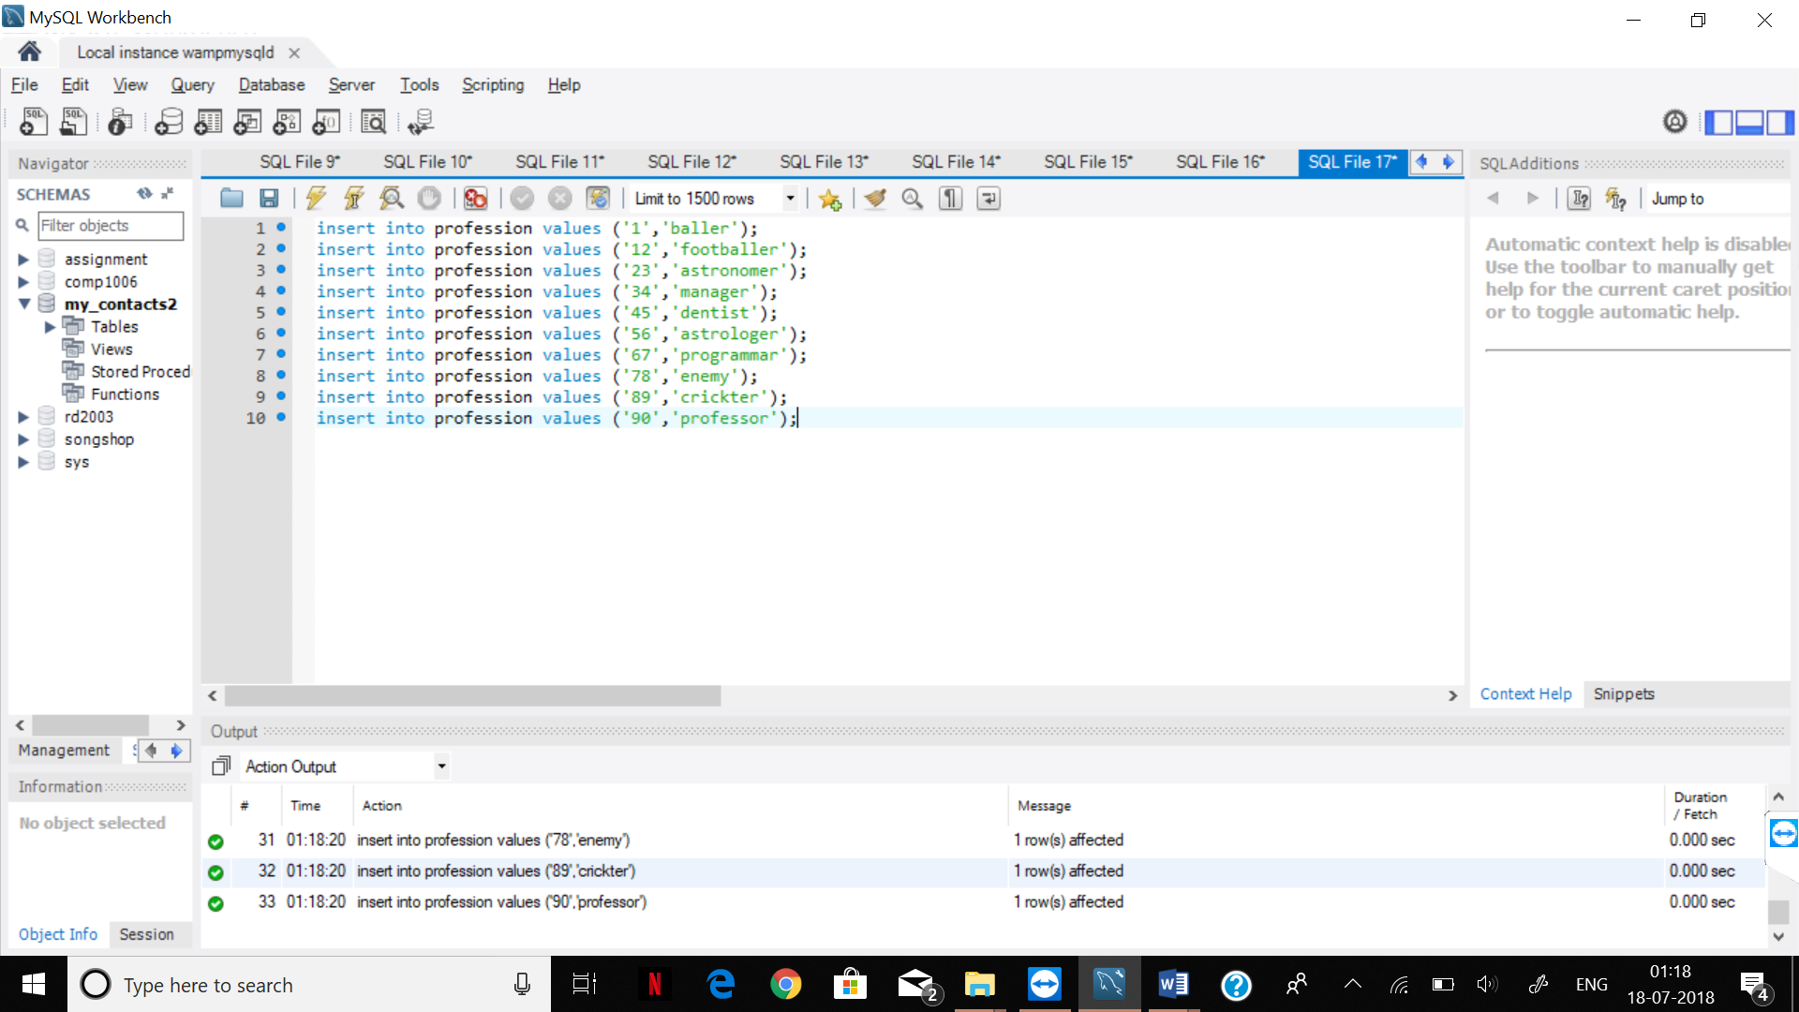

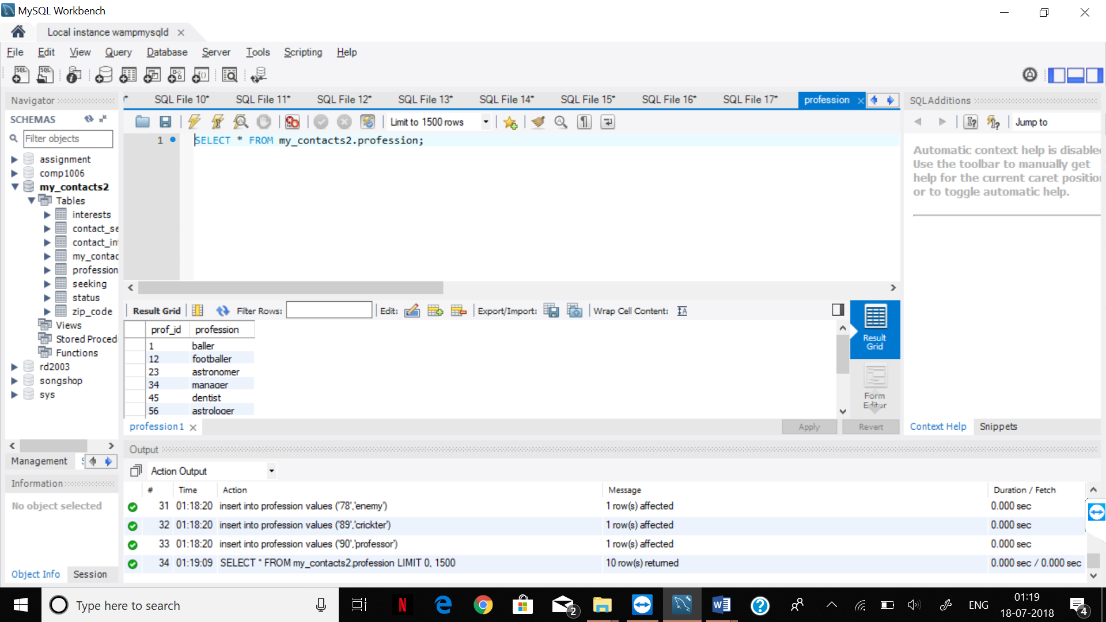

2)

insert into zip_code values ('123','Mississ','ON');

insert into zip_code values ('234','Malton','ON');

insert into zip_code values ('345','Toronto', 'ON');

insert into zip_code values ('456','Calgary','AB');

insert into zip_code values ('567','RichmondHill','NY');

insert into zip_code values ('678','Newmarket','ON');

insert into zip_code values ('789','Orillia','ON');

insert into zip_code values ('890','Milwaukee','Winconsin');

insert into zip_code values ('901','Muskoka','ON');

insert into zip_code values ('12','Oshawa','ON');

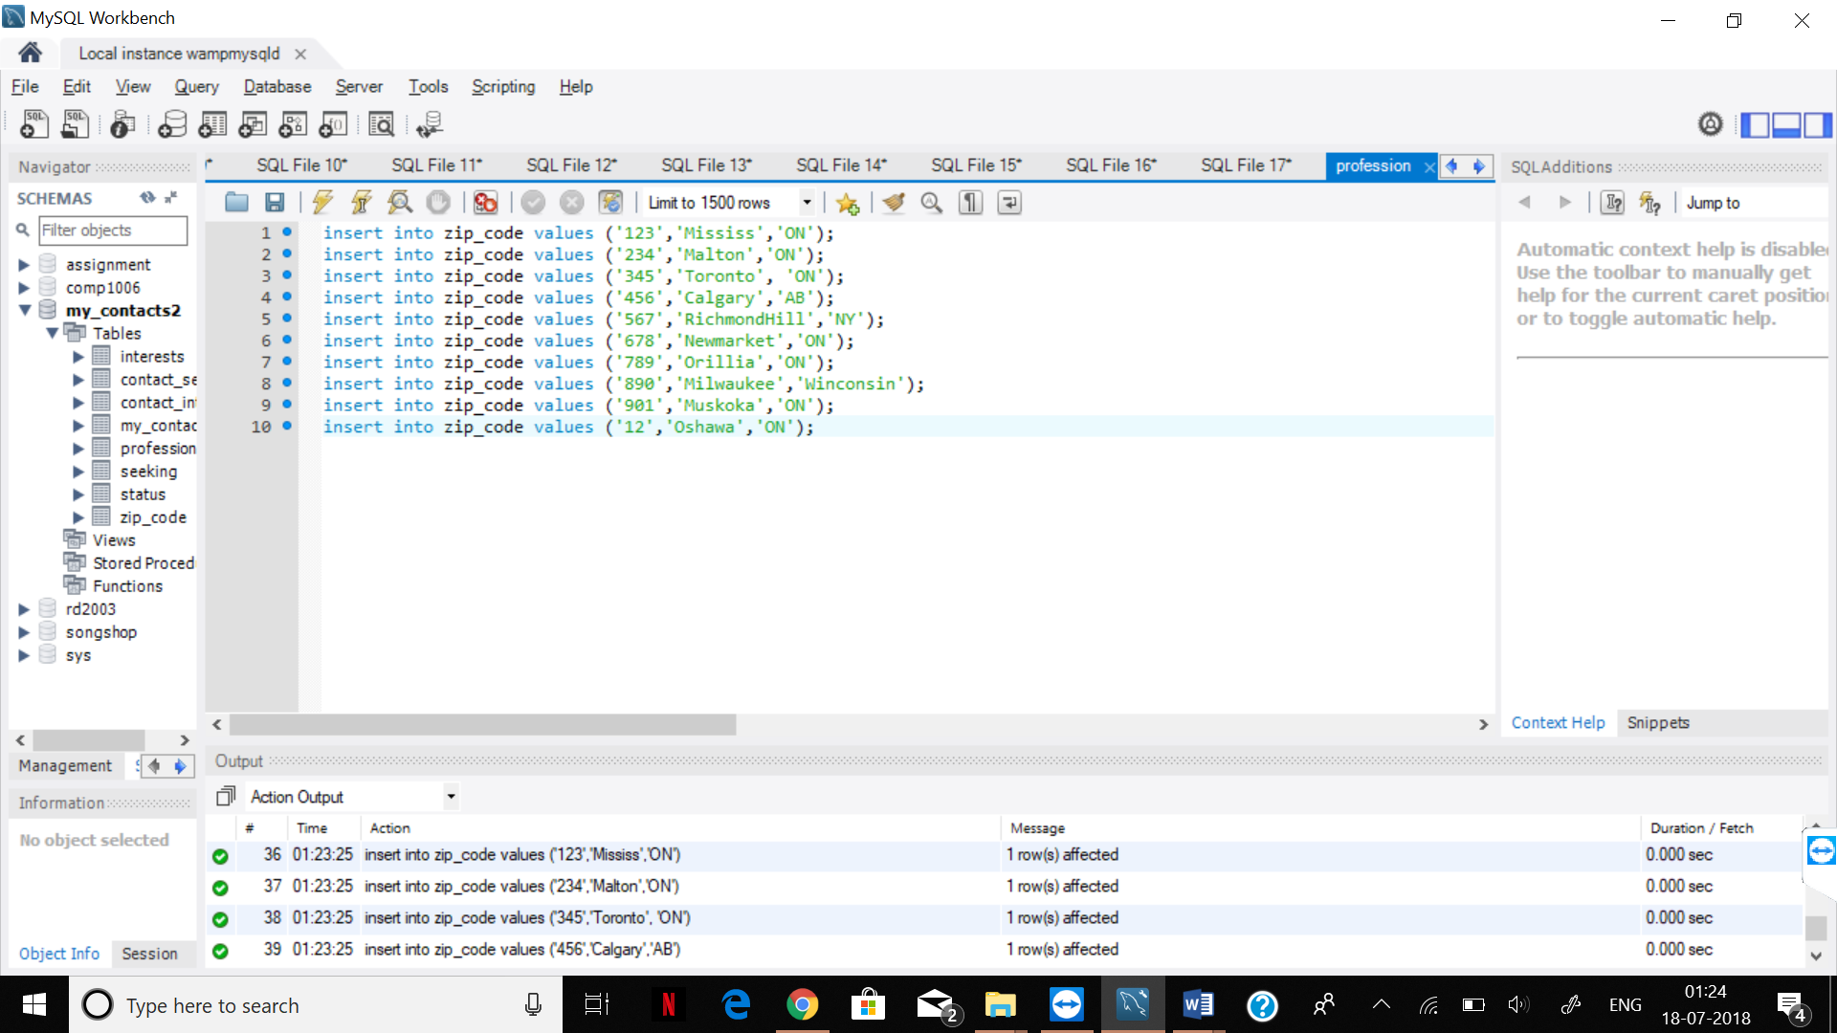

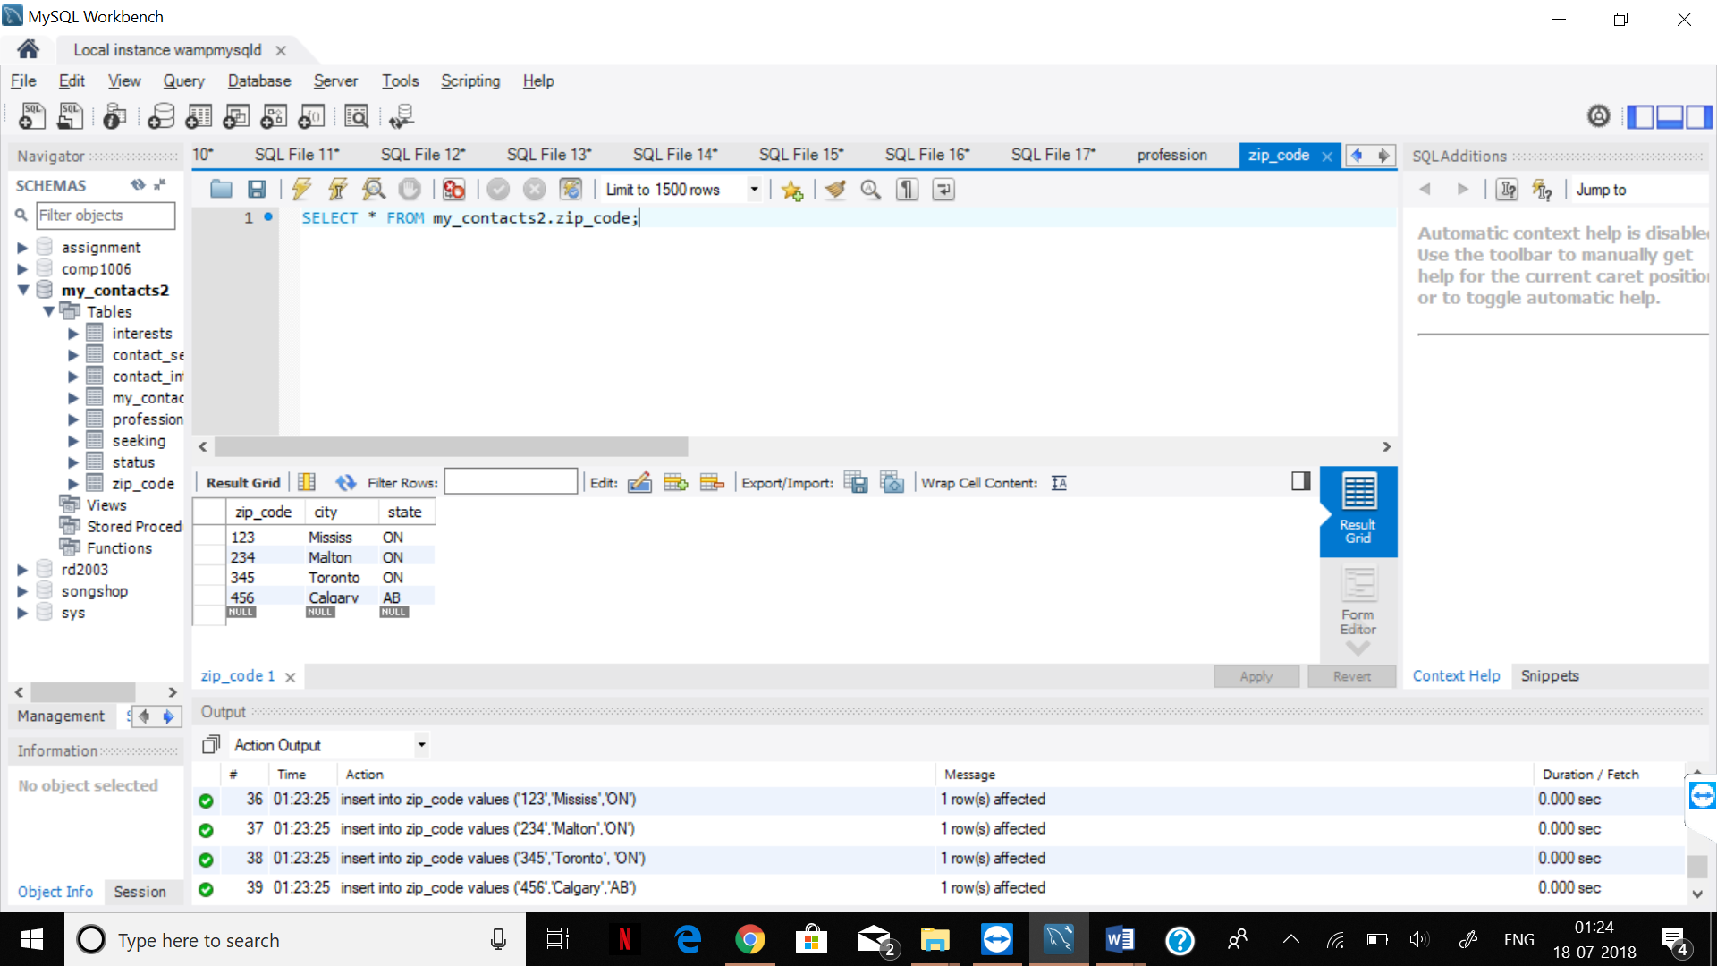

3) insert into status values ('1234','Married');

insert into status values ('2345','Married');

insert into status values ('3456','Divorced');

insert into status values ('4567','Single');

insert into status values ('5678','Married');

insert into status values ('6789','Single');

insert into status values ('7890','Married');

insert into status values ('8901','Divorced');

insert into status values ('9012','Single');

insert into status values ('0123','Single');

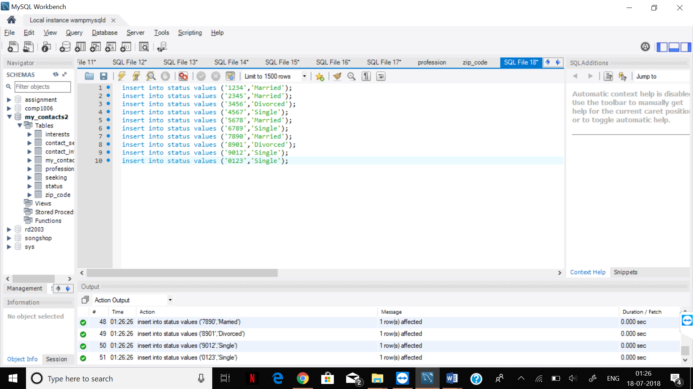

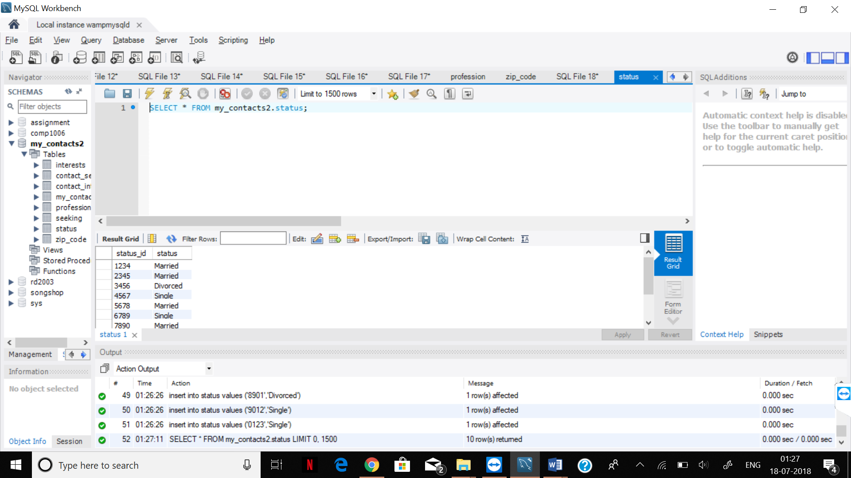

4) insert into contact_interest values ('1','11');

insert into contact_interest values ('12','1');

insert into contact_interest values ('15','14');

insert into contact_interest values ('17','15');

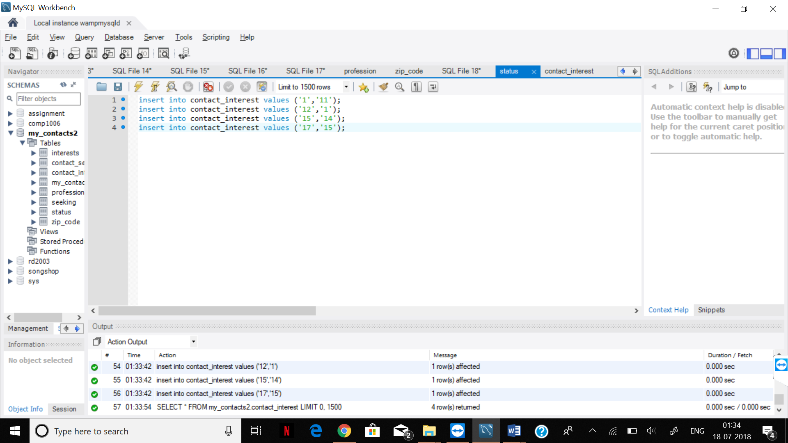

5) insert into contact_seeking values ('1','21');

insert into contact_seeking values ('12','2');

insert into contact_seeking values ('15','24');

insert into contact_seeking values ('17','25');

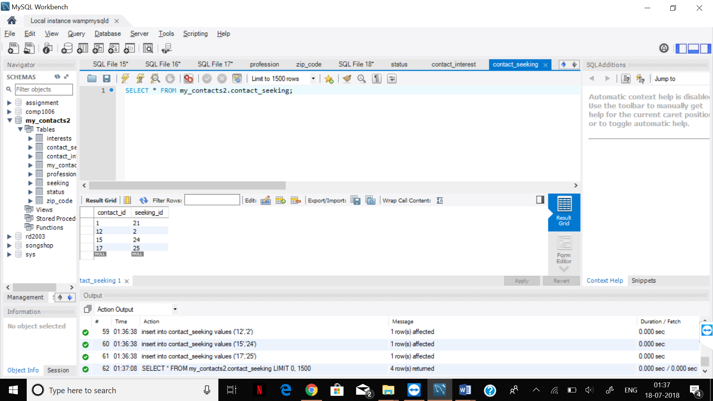

6) insert into interests values ('11','music');

insert into interests values ('1','gym');

insert into interests values ('14','food') ;

insert into interests values ('15','cooking');

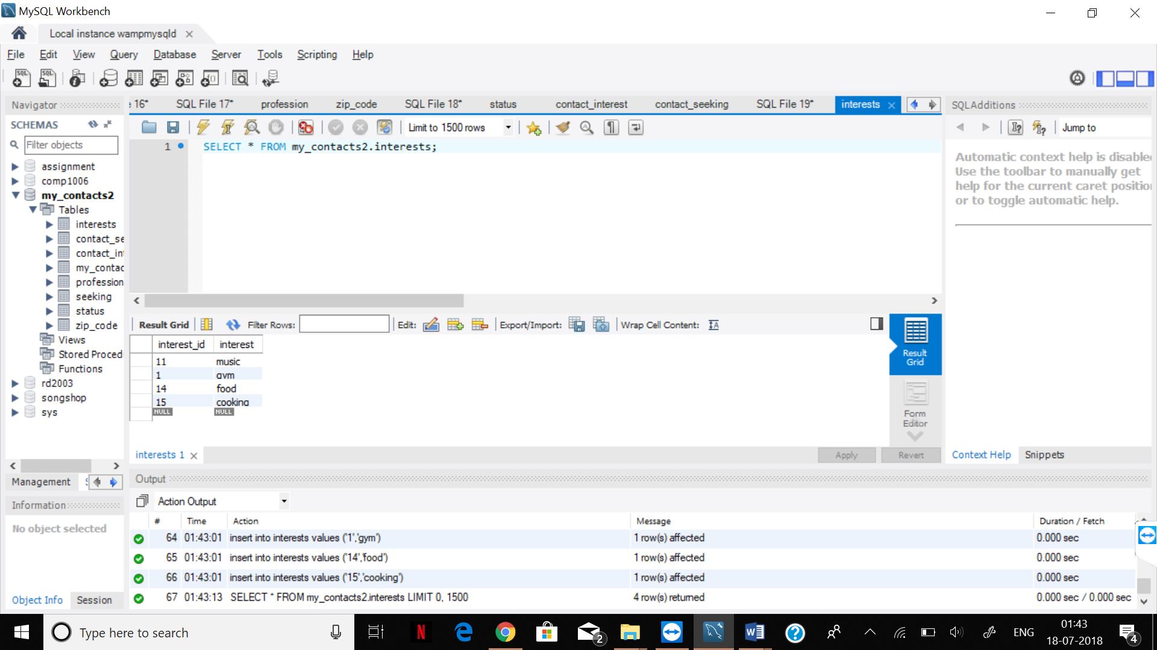

7) insert into seeking values ('1','girl');

insert into seeking values ('2','women');

insert into seeking values ('24','guy') ;

insert into seeking values ('25','boy');

